GREETHAM PARISH COUNCIL
STANDING 0RDERS

Reviewed and Approved on 10/05/23

Information on revisions
Date | Revision
13/04/22 | - Temporary Amendment made on 15/4/20 regarding zoom meetings during Covid pandemic removed.
08/06/22 | - Amendments made to Financial Regulations to include the process for BACS payments and the introduction of a General Reserves Policy.
14/04/23 | - Amendments made to Appendix 1 – Code of Conduct – New Code of Conduct approved on 12/4/23
04/05/23 | - Amendments made to Appendix 6 – Advisory Teams

These Standing Orders provide procedures and controls for the management of Council business. Basic arrangements are contained in Schedule 12 of the Local Government Act 1972. The procedural requirements in Schedule 12, together with other requirements appropriate for the Council, are incorporated. Standing Orders should be seen as an aid to proper and effective governance. Over regulation can be an impediment. References to the Chairman in these Standing Orders include the Vice Chairman and any other Councillor when acting as Chairman.
Standing Orders in bold type contain legal and statutory requirements.

Table of Contents
1. RULES OF DEBATE AT MEETINGS 3
2. DISORDERLY CONDUCT AT MEETINGS 4
4. COMMITTEES AND SUB-COMMITTEES 7
5. ORDINARY COUNCIL MEETINGS 8
6. EXTRAORDINARY MEETINGS OF COUNCIL / COMMITTEES / SUB-COMMITTEES 10
7. PREVIOUS RESOLUTIONS 10
8. VOTING ON APPOINTMENTS 10
9. MOTIONS FOR A MEETING THAT REQUIRE WRITTEN NOTICE 11
10. MOTIONS AT A MEETING THAT DO NOT REQUIRE WRITTEN NOTICE 11
12. DRAFT MINUTES 12
13. CODE OF CONDUCT AND DISPENSATIONS 13
14. CODE OF CONDUCT COMPLAINTS 14
15. PROPER OFFICER 15
16. RESPONSIBLE FINANCIAL OFFICER 16
18. FINANCIAL CONTROLS AND PROCUREMENT 17
19. HANDLING STAFF MATTERS 18
20. RESPONSIBILITIES TO PROVIDE INFORMATION 19
23. EXECUTION AND SEALING OF LEGAL DEEDS 19
25. RESTRICTIONS ON COUNCILLOR ACTIVITIES 20
26. STANDING ORDERS GENERALLY 20
Appendix 1 Code of conduct 21
Appendix 2 Freedom of information 22
Appendix 3 Complaints 23
Appendix 4 Correspondence 24
Appendix 5 Financial Regulations 25
Appendix 6 Advisory Teams 30
Appendix 7 Co-option process 32
Appendix 8 Transparency Regulations 33
Appendix 9 Safeguarding Policy 34
Appendix 10 Equality Policy 36

RULES OF DEBATE AT MEETINGS
- Motions on the agenda shall be considered in the order that they appear unless the order is changed at the discretion of the chairman of the meeting.
- A motion (including an amendment) shall not be progressed unless it has been moved and seconded.
- A motion on the agenda that is not moved by its proposer may be treated by the chairman of the meeting as withdrawn.
- If a motion (including an amendment) has been seconded, it may be withdrawn by the proposer only with the consent of the seconder and the meeting.
- An amendment is a proposal to remove or add words to a motion. It shall not negate the motion.
- If an amendment to the original motion is carried, the original motion (as amended) becomes the substantive motion upon which further amendment(s) may be moved.
- An amendment shall not be considered unless early verbal notice of it is given at the meeting and, if requested by the chairman of the meeting, is expressed in writing to the chairman.
- A councillor may move an amendment to his own motion if agreed by the meeting. If a motion has already been seconded, the amendment shall be with the consent of the seconder and the meeting.
- If there is more than one amendment to an original or substantive motion, the amendments shall be moved in the order directed by the chairman of the meeting.
- Subject to standing order 1(k), only one amendment shall be moved and debated at a time, the order of which shall be directed by the chairman of the meeting.
- One or more amendments may be discussed together if the chairman of the meeting considers this expedient but each amendment shall be voted upon separately.
- A councillor may not move more than one amendment to an original or substantive motion.
- The mover of an amendment has no right of reply at the end of debate on it.
- Where a series of amendments to an original motion are carried, the mover of the original motion shall have a right of reply either at the end of debate on the first amendment or at the very end of debate on the final substantive motion immediately before it is put to the vote.
- Unless permitted by the chairman of the meeting, a councillor may speak once in the debate on a motion except:
- to speak on an amendment moved by another councillor;
- to move or speak on another amendment if the motion has been amended since he last spoke;
- to make a point of order;
- to give a personal explanation; or
- to exercise a right of reply.
- During the debate on a motion, a councillor may interrupt only on a point of order or a personal explanation and the councillor who was interrupted shall stop speaking. A councillor raising a point of order shall identify the standing order which he considers has been breached or specify the other irregularity in the proceedings of the meeting he is concerned by.
- A point of order shall be decided by the chairman of the meeting and his decision shall be final.
- When a motion is under debate, no other motion shall be moved except:
- to amend the motion;
- to proceed to the next business;
- to adjourn the debate;
- to put the motion to a vote;
- to ask a person to be no longer heard or to leave the meeting;
- to refer a motion to a committee or sub-committee for consideration;
- to exclude the public and press;
- to adjourn the meeting; or
- to suspend particular standing order(s) excepting those which reflect mandatory statutory or legal requirements.
- Before an original or substantive motion is put to the vote, the chairman of the meeting shall be satisfied that the motion has been sufficiently debated and that the mover of the motion under debate has exercised or waived his right of reply.
- Excluding motions moved under standing order 1(r), the contributions or speeches by a councillor shall relate only to the motion under discussion and shall not exceed 3 minutes without the consent of the chairman of the meeting.

DISORDERLY CONDUCT AT MEETINGS
- No person shall obstruct the transaction of business at a meeting or behave offensively or improperly. If this standing order is ignored, the chairman of the meeting shall request such person(s) to moderate or improve their conduct.
- If person(s) disregard the request of the chairman of the meeting to moderate or improve their conduct, any councillor or the chairman of the meeting may move that the person be no longer heard or be excluded from the meeting. The motion, if seconded, shall be put to the vote without discussion.
- If a resolution made under standing order 2(b) is ignored, the chairman of the meeting may take further reasonable steps to restore order or to progress the meeting. This may include temporarily suspending or closing the meeting.

MEETINGS GENERALLY
Full Council meetings §
Committee meetings €
Sub-committee meetings ¢
§ | - Meetings shall not take place in premises which at the time of the meeting are used for the supply of alcohol, unless no other premises are available free of charge or at a reasonable cost.
§ | - The minimum three clear days for notice of a meeting does not include the day on which notice was issued, the day of the meeting, a Sunday, a day of the Christmas break, a day of the Easter break or of a bank holiday or a day appointed for public thanksgiving or mourning.
€ | - The minimum three clear days’ public notice for a meeting does not include the day on which the notice was issued or the day of the meeting unless the meeting is convened at shorter notice.
§  € | - Meetings shall be open to the public unless their presence is prejudicial to the public interest by reason of the confidential nature of the business to be transacted or for other special reasons. The public’s exclusion from part or all of a meeting shall be by a resolution which shall give reasons for the public’s exclusion.
 | - Members of the public may make representations, answer questions and give evidence at a meeting which they are entitled to attend in respect of the business on the agenda.
 | - The period of time designated for public participation at a meeting in accordance with standing order 3(e) shall not exceed 15 minutes unless directed by the chairman of the meeting.
 | - Subject to standing order 3(f), a member of the public shall not speak for more than 3 minutes.
 | - In accordance with standing order 3(e), a question shall not require a response at the meeting nor start a debate on the question. The chairman of the meeting may direct that a written or oral response be given.
 | - (Not adopted)
 | - A person who speaks at a meeting shall direct his comments to the chairman of the meeting.
 | - Only one person is permitted to speak at a time. If more than one person wants to speak, the chairman of the meeting shall direct the order of speaking.
§  € | - Subject to standing order 3(m), a person who attends a meeting is permitted to report on the meeting whilst the meeting is open to the public. To “report” means to film, photograph, make an audio recording of meeting proceedings, use any other means for enabling persons not present to see or hear the meeting as it takes place or later or to report or to provide oral or written commentary about the meeting so that the report or commentary is available as the meeting takes place or later to persons not present.
§  € | - A person present at a meeting may not provide an oral report or oral commentary about a meeting as it takes place without permission.
§  € | - The press shall be provided with reasonable facilities for the taking of their report of all or part of a meeting at which they are entitled to be present.
§ | - Subject to standing orders which indicate otherwise, anything authorised or required to be done by, to or before the Chairman of the Council may in his absence be done by, to or before the Vice-Chairman of the Council (if there is one).
§ | - The Chairman of the Council, if present, shall preside at a meeting. If the Chairman is absent from a meeting, the Vice-Chairman of the Council (if there is one) if present, shall preside. If both the Chairman and the Vice-Chairman are absent from a meeting, a councillor as chosen by the councillors present at the meeting shall preside at the meeting.
§  €  § | - Subject to a meeting being quorate, all questions at a meeting shall be decided by a majority of the councillors and non-councillors with voting rights present and voting.
§  €  ¢ | - The chairman of a meeting may give an original vote on any matter put to the vote, and in the case of an equality of votes may exercise his casting vote whether or not he gave an original vote.  See standing orders 5(h) and (i) for the different rules that apply in the election of the Chairman of the Council at the annual meeting of the Council.
§ | - Unless standing orders provide otherwise, voting on a question shall be by a show of hands. At the request of a councillor, the voting on any question shall be recorded so as to show whether each councillor present and voting gave his vote for or against that question. Such a request shall be made before moving on to the next item of business on the agenda.
- The minutes of a meeting shall include an accurate record of the following:
- the time and place of the meeting;
- the names of councillors who are present and the names of councillors who are absent;
- interests that have been declared by councillors and non-councillors with voting rights;
- the grant of dispensations (if any) to councillors and non-councillors with voting rights;
- whether a councillor or non-councillor with voting rights left the meeting when matters that they held interests in were being considered;
- if there was a public participation session; and
- the resolutions made.
§  €  ¢ | - A councillor or a non-councillor with voting rights who has a disclosable pecuniary interest or another interest as set out in the Council’s code of conduct in a matter being considered at a meeting is subject to statutory limitations or restrictions under the code on his right to participate and vote on that matter.
§ | - No business may be transacted at a meeting unless at least one-third of the whole number of members of the Council are present and in no case shall the quorum of a meeting be less than three.  See standing order 4d(viii) for the quorum of a committee or sub-committee meeting.
§  €  € | - If a meeting is or becomes inquorate no business shall be transacted and the meeting shall be closed. The business on the agenda for the meeting shall be adjourned to another meeting.
 | - A meeting shall not exceed a period of 2 hours.

COMMITTEES AND SUB-COMMITTEES
- Unless the Council determines otherwise, a committee may appoint a sub-committee whose terms of reference and members shall be determined by the committee.
- The members of a committee may include non-councillors unless it is a committee which regulates and controls the finances of the Council.
- Unless the Council determines otherwise, all the members of an advisory committee and a sub-committee of the advisory committee may be non-councillors.
- The Council may appoint standing committees or other committees as may be necessary, and:
- shall determine their terms of reference;
- shall determine the number and time of the ordinary meetings of a standing committee up until the date of the next annual meeting of the Council;
- shall permit a committee, other than in respect of the ordinary meetings of a committee, to determine the number and time of its meetings;
- shall, subject to standing orders 4(b) and (c), appoint and determine the terms of office of members of such a committee;
- may, subject to standing orders 4(b) and (c), appoint and determine the terms of office of the substitute members to a committee whose role is to replace the ordinary members at a meeting of a committee if the ordinary members o the committee confirm to the Proper Officer 5 days before the meeting that they are unable to attend;
- shall, after it has appointed the members of a standing committee, appoint the chairman of the standing committee;
- shall permit a committee other than a standing committee, to appoint its own chairman at the first meeting of the committee;
- shall determine the place, notice requirements and quorum for a meeting of a committee and a sub-committee which, in both cases, shall be no less than three;
- shall determine if the public may participate at a meeting of a committee;
- shall determine if the public and press are permitted to attend the meetings of a sub-committee and also the advance public notice requirements, if any, required for the meetings of a sub-committee;
- shall determine if the public may participate at a meeting of a sub-committee that they are permitted to attend; and
- may dissolve a committee or a sub-committee.

ORDINARY COUNCIL MEETINGS
- In an election year, the annual meeting of the Council shall be held on or within 14 days following the day on which the councillors elected take office.
- In a year which is not an election year, the annual meeting of the Council shall be held on such day in May as the Council decides.
- If no other time is fixed, the annual meeting of the Council shall take place at 6pm.
- In addition to the annual meeting of the Council, at least three other ordinary meetings shall be held in each year on such dates and times as the Council decides.
- The first business conducted at the annual meeting of the Council shall be the election of the Chairman and Vice-Chairman (if there is one) of the Council.
- The Chairman of the Council, unless he has resigned or becomes disqualified, shall continue in office and preside at the annual meeting until his successor is elected at the next annual meeting of the Council.
- The Vice-Chairman of the Council, if there is one, unless he resigns or becomes disqualified, shall hold office until immediately after the election of the Chairman of the Council at the next annual meeting of the Council.
- In an election year, if the current Chairman of the Council has not been re-elected as a member of the Council, he shall preside at the annual meeting until a successor Chairman of the Council has been elected. The current Chairman of the Council shall not have an original vote in respect of the election of the new Chairman of the Council but shall give a casting vote in the case of an equality of votes.
- In an election year, if the current Chairman of the Council has been re-elected as a member of the Council, he shall preside at the annual meeting until a new Chairman of the Council has been elected. He may exercise an original vote in respect of the election of the new Chairman of the Council and shall give a casting vote in the case of an equality of votes.
- Following the election of the Chairman of the Council and Vice-Chairman (if there is one) of the Council at the annual meeting, the business shall include:
    - In an election year, delivery by the Chairman of the Council and councillors of their acceptance of office forms unless the Council resolves for this to be done at a later date. In a year which is not an election year, delivery by the Chairman of the Council of his acceptance of office form unless the Council resolves for this to be done at a later date;
    - Confirmation of the accuracy of the minutes of the last meeting of the Council;
    - Receipt of the minutes of the last meeting of a committee;
    - Consideration of the recommendations made by a committee;
    - Review of delegation arrangements to committees, sub-committees, staff and other local authorities;
    - Review of the terms of reference for committees;
    - Appointment of members to existing committees;
    - Appointment of any new committees in accordance with standing order 4;
    - Review and adoption of appropriate standing orders and financial regulations;
    - Review of arrangements (including legal agreements) with other local authorities, not-for-profit bodies and businesses.
    - Review of representation on or work with external bodies and arrangements for reporting back;
    - In an election year, to make arrangements with a view to the Council becoming eligible to exercise the general power of competence in the future;
    - Review of inventory of land and other assets including buildings and office equipment;
    - Confirmation of arrangements for insurance cover in respect of all insurable risks;
    - Review of the Council’s and/or staff subscriptions to other bodies;
    - Review of the Council’s complaints procedure;
    - Review of the Council’s policies, procedures and practices in respect of its obligations under freedom of information and data protection legislation (see also standing orders 11, 20 and 21);
    - Review of the Council’s policy for dealing with the press/media;
    - Review of the Council’s employment policies and procedures;
    - Review of the Council’s expenditure incurred under s.137 of the Local Government Act 1972 or the general power of competence.
    - Determining the time and place of ordinary meetings of the Council up to and including the next annual meeting of the Council.

EXTRAORDINARY MEETINGS OF COUNCIL / COMMITTEES / SUB-COMMITTEES
- The Chairman of the Council may convene an extraordinary meeting of the Council at any time.
- If the Chairman of the Council does not call an extraordinary meeting of the Council within seven days of having been requested in writing to do so by two councillors, any two councillors may convene an extraordinary meeting of the Council. The public notice giving the time, place and agenda for such a meeting shall be signed by the two councillors.
- The chairman of a committee [or a sub-committee] may convene an extraordinary meeting of the committee [or the sub-committee] at any time.
- If the chairman of a committee [or a sub-committee] does not call an extraordinary meeting within ( ) days of having been requested to do so by ( ) members of the committee [or the sub-committee], any ( ) members of the committee [or the subcommittee] may convene an extraordinary meeting of the committee [or a sub-committee].

PREVIOUS RESOLUTIONS
- A resolution shall not be reversed within six months except either by a special motion, which requires written notice by at least 3 councillors to be given to the Proper Officer in accordance with standing order 9, or by a motion moved in pursuance of the recommendation of a committee or a sub-committee.
- When a motion moved pursuant to standing order 7(a) has been disposed of, no similar motion may be moved for a further six months.

VOTING ON APPOINTMENTS
- Where more than two persons have been nominated for a position to be filled by the Council and none of those persons has received an absolute majority of votes in their favour, the name of the person having the least number of votes shall be struck off the list and a fresh vote taken. This process shall continue until a majority of votes is given in favour of one person. A tie in votes may be settled by the casting vote exercisable by the chairman of the meeting.

MOTIONS FOR A MEETING THAT REQUIRE WRITTEN NOTICE
- A motion shall relate to the responsibilities of the meeting for which it is tabled and in any event shall relate to the performance of the Council’s statutory functions, powers and obligations or an issue which specifically affects the Council’s area or its residents.
- No motion may be moved at a meeting unless it is on the agenda and the mover has given written notice of its wording to the Proper Officer at least 7 clear days before the meeting. Clear days do not include the day of the notice or the day of the meeting.
- The Proper Officer may, before including a motion on the agenda received in accordance with standing order 9(b), correct obvious grammatical or typographical errors in the wording of the motion.
- If the Proper Officer considers the wording of a motion received in accordance with standing order 9(b) is not clear in meaning, the motion shall be rejected until the mover of the motion resubmits it, so that it can be understood, in writing, to the Proper Officer at least 4 clear days before the meeting.
- If the wording or subject of a proposed motion is considered improper, the Proper Officer shall consult with the chairman of the forthcoming meeting or, as the case may be, the councillors who have convened the meeting, to consider whether the motion shall be included in the agenda or rejected.
- The decision of the Proper Officer as to whether or not to include the motion on the agenda shall be final.
- Motions received shall be recorded and numbered in the order that they are received.
- Motions rejected shall be recorded with an explanation by the Proper Officer of the reason for rejection.

MOTIONS AT A MEETING THAT DO NOT REQUIRE WRITTEN NOTICE
- The following motions may be moved at a meeting without written notice to the Proper Officer:
  - to correct an inaccuracy in the draft minutes of a meeting;
  - to move to a vote;
  - to defer consideration of a motion;
  - to refer a motion to a particular committee or sub-committee;
  - to appoint a person to preside at a meeting;
  - to change the order of business on the agenda;
  - to proceed to the next business on the agenda;
  - to require a written report;
  - to appoint a committee or sub-committee and their members;
  - to extend the time limits for speaking;
  - to exclude the press and public from a meeting in respect of confidential or other information which is prejudicial to the public interest;
  - to not hear further from a councillor or a member of the public;
  - to exclude a councillor or member of the public for disorderly conduct;
  - to temporarily suspend the meeting;
  - to suspend a particular standing order (unless it reflects mandatory statutory or legal requirements);
  - to adjourn the meeting; or
  - to close the meeting.

MANAGEMENT OF INFORMATION
See also standing order 20.
- The Council shall have in place and keep under review, technical and organisational measures to keep secure information (including personal data) which it holds in paper and electronic form. Such arrangements shall include deciding who has access to personal data and encryption of personal data.
- The Council shall have in place, and keep under review, policies for the retention and safe destruction of all information (including personal data) which it holds in paper and electronic form. The Council’s retention policy shall confirm the period for which information (including personal data) shall be retained or if this is not possible the criteria used to determine that period (e.g. the Limitation Act 1980).
- The agenda, papers that support the agenda and the minutes of a meeting shall not disclose or otherwise undermine confidential information or personal data without legal justification.
- Councillors, staff, the Council’s contractors and agents shall not disclose confidential information or personal data without legal justification.

DRAFT MINUTES
Full Council meetings §
Committee meetings €
Sub-committee meetings ¢
 | - If the draft minutes of a preceding meeting have been served on councillors with the agenda to attend the meeting at which they are due to be approved for accuracy, they shall be taken as read.
 | - There shall be no discussion about the draft minutes of a preceding meeting except in relation to their accuracy. A motion to correct an inaccuracy in the draft minutes shall be moved in accordance with standing order 10(a)(i).
 | - The accuracy of draft minutes, including any amendment(s) made to them, shall be confirmed by resolution and shall be signed by the chairman of the meeting and stand as an accurate record of the meeting to which the minutes relate.
- If the chairman of the meeting does not consider the minutes to be an accurate record of the meeting to which they relate, he shall sign the minutes and include a paragraph in the following terms or to the same effect:
“The chairman of this meeting does not believe that the minutes of the meeting of the ( ) held on [date] in respect of ( ) were a correct record but his view was not upheld by the meeting and the minutes are confirmed as an accurate record of the proceedings.”
§  €  ¢ | - If the Council’s gross annual income or expenditure (whichever is higher) does not exceed £25,000, it shall publish draft minutes on a website which is publicly accessible and free of charge not later than one month after the meeting has taken place.
 | - Subject to the publication of draft minutes in accordance with standing order 12(e) and standing order 20(a) and following a resolution which confirms the accuracy of the minutes of a meeting, the draft minutes or recordings of the meeting for which approved minutes exist shall be destroyed.

CODE OF CONDUCT AND DISPENSATIONS
See also standing order 3(u).
- All councillors and non-councillors with voting rights shall observe the code of conduct adopted by the Council.
- Unless he has been granted a dispensation, a councillor or non-councillor with voting rights shall withdraw from a meeting when it is considering a matter in which he has a disclosable pecuniary interest. He may return to the meeting after it has considered the matter in which he had the interest.
- Unless he has been granted a dispensation, a councillor or non-councillor with voting rights shall withdraw from a meeting when it is considering a matter in which he has another interest if so required by the Council’s code of conduct. He may return to the meeting after it has considered the matter in which he had the interest.
- Dispensation requests shall be in writing and submitted to the Proper Officer as soon as possible before the meeting, or failing that, at the start of the meeting for which the dispensation is required.
- A decision as to whether to grant a dispensation shall be made [by the Proper Officer] OR [by a meeting of the Council, or committee or sub-committee for which the dispensation is required] and that decision is final.
- A dispensation request shall confirm:
    - the description and the nature of the disclosable pecuniary interest or other interest to which the request for the dispensation relates;
    - whether the dispensation is required to participate at a meeting in a discussion only or a discussion and a vote;
    - the date of the meeting or the period (not exceeding four years) for which the dispensation is sought; and
    - an explanation as to why the dispensation is sought.
- Subject to standing orders 13(d) and (f), a dispensation request shall be considered [by the Proper Officer before the meeting or, if this is not possible, at the start of the meeting for which the dispensation is required] OR [at the beginning of the meeting of the Council, or committee or sub-committee for which the dispensation is required].
- A dispensation may be granted in accordance with standing order 13(e) if having regard to all relevant circumstances any of the following apply:
  - without the dispensation the number of persons prohibited from participating in the particular business would be so great a proportion of the meeting transacting the business as to impede the transaction of the business;
  - granting the dispensation is in the interests of persons living in the Council’s area; or
  - it is otherwise appropriate to grant a dispensation.

CODE OF CONDUCT COMPLAINTS
- Upon notification by the District or Unitary Council that it is dealing with a complaint that a councillor or non-councillor with voting rights has breached the Council’s code of conduct, the Proper Officer shall, subject to standing order 11, report this to the Council.
- Where the notification in standing order 14(a) relates to a complaint made by the Proper Officer, the Proper Officer shall notify the Chairman of Council of this fact, and the Chairman shall nominate another staff member to assume the duties of the Proper Officer in relation to the complaint until it has been determined and the Council has agreed what action, if any, to take in accordance with standing order 14(d).
- The Council may:
  - provide information or evidence where such disclosure is necessary to investigate the complaint or is a legal requirement;
  - seek information relevant to the complaint from the person or body with statutory responsibility for investigation of the matter;
- Upon notification by the District or Unitary Council that a councillor or non-councillor with voting rights has breached the Council’s code of conduct, the Council shall consider what, if any, action to take against him. Such action excludes disqualification or suspension from office.

PROPER OFFICER
- The Proper Officer shall be either (i) the clerk or (ii) other staff member(s) nominated by the Council to undertake the work of the Proper Officer when the Proper Officer is absent.
- The Proper Officer shall:
  - at least three clear days before a meeting of the council, a committee or a sub-committee,
- serve on councillors by delivery or post at their residences or by email authenticated in such manner as the Proper Officer thinks fit, a signed summons confirming the time, place and the agenda (provided the councillor has consented to service by email), and
- Provide, in a conspicuous place, public notice of the time, place and agenda (provided that the public notice with agenda of an extraordinary meeting of the Council convened by councillors is signed by them).
See standing order 3(b) for the meaning of clear days for a meeting of a full council and standing order 3(c) for the meaning of clear days for a meeting of a committee;
  - subject to standing order 9, include on the agenda all motions in the order received unless a councillor has given written notice at least 4 days before the meeting confirming his withdrawal of it;
  - convene a meeting of the Council for the election of a new Chairman of the Council, occasioned by a casual vacancy in his office;
  - facilitate inspection of the minute book by local government electors;
  - receive and retain copies of byelaws made by other local authorities;
  - hold acceptance of office forms from councillors;
  - hold a copy of every councillor’s register of interests;
  - assist with responding to requests made under freedom of information legislation and rights exercisable under data protection legislation, in accordance with the Council’s relevant policies and procedures;
  - liaise, as appropriate, with the Council’s Data Protection Officer (if there is one);
  - receive and send general correspondence and notices on behalf of the Council except where there is a resolution to the contrary;
  - assist in the organisation of, storage of, access to, security of and destruction of information held by the Council in paper and electronic form subject to the requirements of data protection and freedom of information legislation and other legitimate requirements (e.g. the Limitation Act 1980);
  - arrange for legal deeds to be executed;
(see also standing order 23);
  - arrange or manage the prompt authorisation, approval, and instruction regarding any payments to be made by the Council in accordance with its financial regulations;
  - record every planning application notified to the Council and the Council’s response to the local planning authority in a book for such purpose;
  - refer a planning application received by the Council to the [Chairman or in his absence the Vice-Chairman (if there is one) of the Council] within two working days of receipt to facilitate an extraordinary meeting if the nature of a planning application requires consideration before the next ordinary meeting of [the Council];
  - manage access to information about the Council via the publication scheme; and
  - retain custody of the seal of the Council (if there is one) which shall not be used without a resolution to that effect.
(see also standing order 23).

RESPONSIBLE FINANCIAL OFFICER
The Responsible Finance Officer (RFO) is a statutory office and appointed by the Council. The Clerk of the Council will take on this role of managing the Council’s financial affairs in accordance with Proper Practices.

ACCOUNTS AND ACCOUNTING STATEMENTS
- “Proper practices” in standing orders refer to the most recent version of “Governance and Accountability for Local Councils – a Practitioners’ Guide”.
- All payments by the Council shall be authorised, approved and paid in accordance with the law, proper practices and the Council’s financial regulations.
- The Responsible Financial Officer shall supply to each councillor as soon as practicable after 30 June, 30 September and 31 December in each year a statement to summarise:
    - the Council’s receipts and payments (or income and expenditure) for each quarter;
    - the Council’s aggregate receipts and payments (or income and expenditure) for the year to date;
    - the balances held at the end of the quarter being reported and
which includes a comparison with the budget for the financial year and highlights any actual or potential overspends.
- As soon as possible after the financial year end at 31 March, the Responsible Financial Officer shall provide:
    - each councillor with a statement summarising the Council’s receipts and payments (or income and expenditure) for the last quarter and the year to date for information; and
    - to the Council the accounting statements for the year in the form of Section 2 of the annual governance and accountability return, as required by proper practices, for consideration and approval.
- The year-end accounting statements shall be prepared in accordance with proper practices and apply the form of accounts determined by the Council (receipts and payments, or income and expenditure) for the year to 31 March. A completed draft annual governance and accountability return shall be presented to all councillors at least 14 days prior to anticipated approval by the Council. The annual governance and accountability return of the Council, which is subject to external audit, including the annual governance statement, shall be presented to the Council for consideration and formal approval before 30 June.

FINANCIAL CONTROLS AND PROCUREMENT
- The Council shall consider and approve financial regulations drawn up by the Responsible Financial Officer, which shall include detailed arrangements in respect of the following:
- the keeping of accounting records and systems of internal controls;
- the assessment and management of financial risks faced by the Council;
- the work of the independent internal auditor in accordance with proper practices and the receipt of regular reports from the internal auditor, which shall be required at least annually;
- the inspection and copying by councillors and local electors of the Council’s accounts and/or orders of payments; and
- whether contracts with an estimated value below £25,000 due to special circumstances are exempt from a tendering process or procurement exercise.
- Financial regulations shall be reviewed regularly and at least annually for fitness of purpose.
- A public contract regulated by the Public Contracts Regulations 2015 with an estimated value in excess of £25,000 but less than the relevant thresholds in standing order 18(f) is subject to Regulations 109-114 of the Public Contracts Regulations 2015 which include a requirement on the Council to advertise the contract opportunity on the Contracts Finder website regardless of what other means it uses to advertise the opportunity unless it proposes to use an existing list of approved suppliers (framework agreement).
- Subject to additional requirements in the financial regulations of the Council, the tender process for contracts for the supply of goods, materials, services or the execution of works shall include, as a minimum, the following steps:
- a specification for the goods, materials, services or the execution of works shall be drawn up;
- an invitation to tender shall be drawn up to confirm (i) the Council’s specification (ii) the time, date and address for the submission of tenders (iii) the date of the Council’s written response to the tender and (iv) the prohibition on prospective contractors contacting councillors or staff to encourage or support their tender outside the prescribed process;
- the invitation to tender shall be advertised in a local newspaper and in any other manner that is appropriate;
- tenders are to be submitted in writing in a sealed marked envelope addressed to the Proper Officer;
- tenders shall be opened by the Proper Officer in the presence of at least one councillor after the deadline for submission of tenders has passed;
- tenders are to be reported to and considered by the appropriate meeting of the Council or a committee or sub-committee with delegated responsibility.
- Neither the Council, nor a committee or a sub-committee with delegated responsibility for considering tenders, is bound to accept the lowest value tender.
- A public contract regulated by the Public Contracts Regulations 2015 with an estimated value in excess of £181,302 for a public service or supply contract or in excess of £4,551,413 for a public works contract (or other thresholds determined by the European Commission every two years and published in the Official Journal of the European Union (OJEU)) shall comply with the relevant procurement procedures and other requirements in the Public Contracts Regulations 2015 which include advertising the contract opportunity on the Contracts Finder website and in OJEU.
- A public contract in connection with the supply of gas, heat, electricity, drinking water, transport services, or postal services to the public; or the provision of a port or airport; or the exploration for or extraction of gas, oil or solid fuel with an estimated value in excess of £363,424 for a supply, services or design contract; or in excess of £4,551,413 for a works contract; or £820,370 for a social and other specific services contract (or other thresholds determined by the European Commission every two years and published in OJEU) shall comply with the relevant procurement procedures and other requirements in the Utilities Contracts Regulations 2016.

HANDLING STAFF MATTERS
- A matter personal to a member of staff that is being considered by a meeting of Council is subject to standing order 11.
- Any persons responsible for all or part of the management of staff shall treat as confidential the written records of all meetings relating to their performance, capabilities, grievance or disciplinary matters.
- In accordance with standing order 11(a), persons with line management responsibilities shall have access to staff records referred to in standing order 19(b).

RESPONSIBILITIES TO PROVIDE INFORMATION
See also standing order 21.
- In accordance with freedom of information legislation, the Council shall publish information in accordance with its publication scheme and respond to requests for information held by the Council.
          - [If gross annual income or expenditure (whichever is higher) does not exceed £25,000] The Council shall publish information in accordance with the requirements of the Smaller Authorities (Transparency Requirements) (England) Regulations 2015.

RESPONSIBILITIES UNDER DATA PROTECTION LEGISLATION
(Below is not an exclusive list).
See also standing order 11.
- The Council may appoint a Data Protection Officer.
- The Council shall have policies and procedures in place to respond to an individual exercising statutory rights concerning his personal data.
- The Council shall have a written policy in place for responding to and managing a personal data breach.
- The Council shall keep a record of all personal data breaches comprising the facts relating to the personal data breach, its effects and the remedial action taken.
- The Council shall ensure that information communicated in its privacy notice(s) is in an easily accessible and available form and kept up to date.
- The Council shall maintain a written record of its processing activities.

RELATIONS WITH THE PRESS/MEDIA
- Requests from the press or other media for an oral or written comment or statement from the Council, its councillors or staff shall be handled in accordance with the Council’s policy in respect of dealing with the press and/or other media.

EXECUTION AND SEALING OF LEGAL DEEDS
See also standing orders 15(b)(xii) and (xvii).
- A legal deed shall not be executed on behalf of the Council unless authorised by a resolution.
Subject to standing order 23(a), any two councillors may sign, on behalf of the Council, any deed required by law and the Proper Officer shall witness their signatures.

COMMUNICATING WITH DISTRICT AND COUNTY OR UNITARY COUNCILLORS
- An invitation to attend a meeting of the Council shall be sent, together with the agenda, to the ward councillor(s) of the RutlandCounty Council representing the area of the Council.
- Unless the Council determines otherwise, a copy of each letter sent to the Rutland County Council shall be sent to the ward councillor(s) representing the area of the Council.

RESTRICTIONS ON COUNCILLOR ACTIVITIES
  - Unless duly authorised no councillor shall:
- inspect any land and/or premises which the Council has a right or duty to inspect; or
- issue orders, instructions or directions.

STANDING ORDERS GENERALLY
- All or part of a standing order, except one that incorporates mandatory statutory or legal requirements, may be suspended by resolution in relation to the consideration of an item on the agenda for a meeting.
- A motion to add to or vary or revoke one or more of the Council’s standing orders, except one that incorporates mandatory statutory or legal requirements, shall be proposed by a special motion, the written notice by at least ( ) councillors to be given to the Proper Officer in accordance with standing order 9.
- The Proper Officer shall provide a copy of the Council’s standing orders to a councillor as soon as possible.
- The decision of the chairman of a meeting as to the application of standing orders at the meeting shall be final.

Appendix 1 Code of conduct

The New Code of Conduct was adopted on 12th April 2023
This is a separate document to the Standing Orders

All members shall observe the Code of Conduct

Notes:
If a Parish Council is in doubt as to whether or not a Disclosable Pecuniary Interest means that they should not be involved in a discussion about a related business matter, they should ask (and be bound by) the advice of the Rutland County Council Monitoring Officer.
If a Parish Councillor fails to withdraw from a discussion on business related to a Disclosable Pecuniary Interest which they have, this could invalidate any conclusions which the Parish Council reach.
Therefore, where the Parish Clerk has on the agenda an item of business and is aware that a Parish Councillor has a Disclosable Pecuniary Interest which may present a conflict of interest, the Clerk should seek guidance from the Rutland County Council Monitoring Officer and advise the Parish Councillor accordingly.

Appendix 2 Freedom of information
This document lays out the procedures by which the Greetham Parish Council will comply with requests for information made under the Freedom of Information Act 2000.
All requests for information should be directed to the clerk.
- Type of information requested | Action
Procedures:  - Standing Orders  - Freedom of information  - Complaints  - Financial procedures  - Burial Ground Rules  - Asset register  - Risk register | The clerk advises the requestor of the cost of providing the information and requests payment in advance.  (Estimate to be based on an “at cost” basis (labour rate £15 per hour plus printing costs plus postage).  Information which can easily be supplied electronically will be provided free.
Records of meetings  Minutes, Agendas | As above
Financial records | As above
Relating to planning applications | As above
Correspondence and replies, including complaints | As above
Information on referenda | As above
Register of interests | As above
Relating to employment of Clerk | Requests relating to employment of the clerk should be referred to the Chairman who will decide what can and cannot be released, bearing in mind the confidentiality of some records. (Data Protection Act 1998), then as above.
Information originating from other official bodies  - Rutland County Council  - Government  - Other bodies | The clerk informs the requestor that they should apply to the official body which produced the document.

Appendix 3 Complaints
This document lays out how complaints should be handled by the Parish Council and its councillors.
Type of complaint | Course of action
Alleged failure of a councillor(s) to comply with the Code of Conduct | Advise the complainant to submit the complaint to the Rutland County Council Monitoring Officer and ensure that the Chairman / Clerk are aware of the allegation immediately.
Alleged criminal activity | Advise the complainant to report the matter to the police and the Rutland County Council Monitoring Officer and ensure that the Chairman / Clerk are aware of the allegation immediately.
Alleged accounting irregularity | In the first instance the clerk should be asked provide an explanation.  If the complainant is not satisfied, the clerk should notify the complainant of the Local elector’s statutory rights under Section 16 of the Audit Commission Act 1998
General complaints, other than above | The complainant should be asked to put their complaint in writing to the Clerk for consideration by the Parish Council at its next meeting.  Alternatively, the person receiving the complaint should record details of the complaint in writing and forward this information to the Clerk.  The clerk will provide a written response to the complainant within 14 days of the matter being discussed at the next parish council meeting.  If the complaint relates to the Clerk, it should be addressed to the Chairman  If the complaint relates to the Chairman, it should be addressed to the Vice Chairman
All complaints | All complaints should be bought to the attention of the Parish Council at the next parish council meeting.

Appendix 4 Correspondence
N.B. ‘Correspondence’ means any communication to the Parish Council in ‘Hard copy’, Written, Fax, E-mail, other digital means or any other format.

Type of correspondence | Course of action
Anonymous correspondence | Anonymous correspondence will be ignored.
Correspondence to the Parish Council and/or Parish Councillors | All correspondence received must be tabled at the ‘correspondence’ section of the next scheduled Parish Council meeting. It can only be withdrawn with a full retraction of the content of such correspondence along with the Chair (Vice in Chair’s absence) and/or Clerk’s approval.
Personal correspondence to an Individual Councillor | Councillors are permitted to use their judgment and discretion as to the presentation of such correspondence to the Parish Council. In practice this means the correspondence could be dealt with as in the above section; or the information contained within such correspondence could be introduced by the Individual Councillor (Initially within the ‘correspondence’ section of the next scheduled Parish Council meeting).

A ‘Correspondence journal’, restricted to written correspondence from village residents only, is to be maintained by the clerk. This to include date received, author, recipient, summary of content, date of inclusion at Parish Council meeting, date and detail of any follow up and/or response.

Appendix 5 Financial Regulations
- There will be one bank account, with Lloyds. No cash will be handled.
- All expenditure must be approved at a Parish Council meeting.
- The Council’s Responsible Financial Officer is the Clerk, Jayne Isaac
The RFO:-
  - acts under the policy direction of the council;
  - administers the Council’s financial affairs in accordance with all Acts, Regulations and proper practices;
  - determines on behalf of the Council its accounting records and accounting control systems;
  - ensures the accounting records are observed;
  - maintains the accounts records of the Council up to date in accordance with proper practices;
  - assists the Council to secure economy, efficiency and effectiveness in the use of its resources; and
  - produces financial management information as required by the Council.
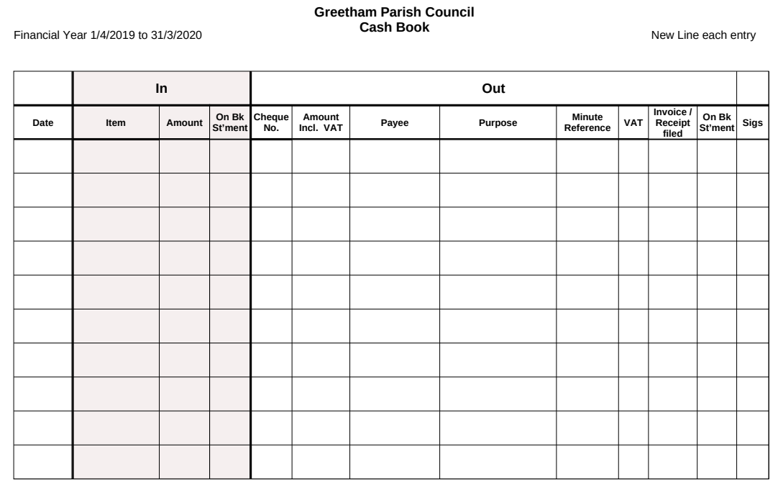
- Before any payment is made, it must be fully recorded in the Cash Book.

- All payments approved at a PC meeting are paid by BACS, but there are some exceptions which need payment by cheque, such as HMRC.
- Blank cheques or cheques not fully completed must never be signed.
- Two signatories are required to authorise a payment in addition to the RFO. For BACS payments there are 3 signatories, the RFO being the first signatory to generate the payment, followed by 2 Councillors to authorise payments. Payments are to be cross referenced against the invoices filed in dropbox.
- The signatories must verify that the Cash Book entry has been completed, the invoice has been cross referenced as to the payment method (i.e. cheque number or date of BACS transfer has been written on it)
- Invoices
  - All invoices for payment shall be examined, verified and certified by the RFO to confirm that the work, goods or services to which each invoice relates has been received, carried out, examined and represents expenditure previously approved by the Council.
  - The RFO shall examine invoices for arithmetical accuracy. The RFO shall take all steps to pay all invoices submitted and which are in order, at the next available council meeting.
  - The RFO shall check that all invoices are annotated as to when and how payment was made and ensure they are safely filed for 5 years.
- Purchasing
  - For contract work, such as grass cutting, tree or hedge work, the Clerk should, where possible seek three quotes for the work and the Parish Council shall decide to whom the work goes. Where this is not practical or possible, the Parish Council may authorise the work to be done on a lesser number of quotes. An official order or letter shall be issued for the work
  - For the purchase of equipment, ideally three prices shall be obtained and the Parish Council shall decide on the supplier. Where this is not possible or practical, the Parish Council may authorise the purchase on a lesser number of prices
  - Neither the Council, nor any committee, is bound to accept the lowest tender, estimate or quote.
- Payment of Clerk’s salary
  - The Clerk will be paid monthly in arrears.
  - The same arrangement as those used by the Greetham Community Centre will be used to manage the Clerk’s PAYE and National Insurance legislation. Pat Evans will advise when and how much tax is due. A cheque of this amount will be given to her as required.
  - The Clerk must be registered under the Government pension arrangements.
- Burial income:
In addition to entries in the Cash Book, a file of all information relating to income from burials will be maintained. i.e.
  - A copy of invoices sent for burial services.
  - A log of the purpose of the income, to whom it relates, grave reference and when payment has been received.
- The Council and any member using computers for Council’s financial business shall ensure that anti-virus software, anti-spyware and firewall software with automatic updates, together with a high level of security is used.
- At the monthly Parish Council meeting, the RFO will table the following:
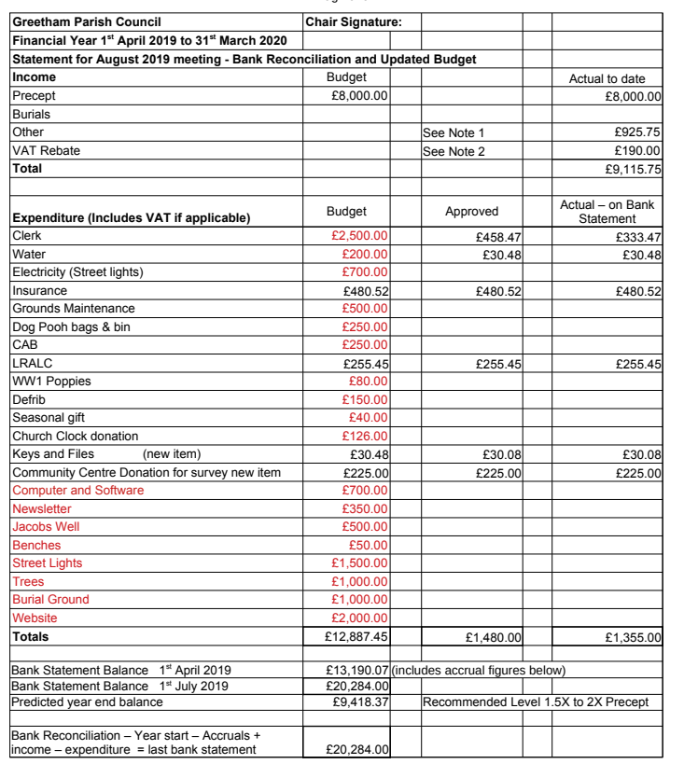
  - An updated budget and bank reconciliation report.

  - An updated list of payments made / approved for the year.
  - A separate tab on the monthly updated budget and bank reconciliation report to track earmarked funds.
  - An up to date Bank Statement.
- It is the responsibility of all Parish Councillors to satisfy themselves that only authorised payments have been made.
- Each month, the Chair will confirm that no unauthorised payments have been made and he has checked the Bank reconciliation. This will be recorded in the minutes.
- Budgets will be set at the January Parish Council meeting at the time a precept is agreed. The precept will be agreed along the following lines:
  - The object will be to maintain a bank balance of (between 3 and 12 months precept) at the year end, in order to have a reserve for unplanned expenditure.
  - Routine expenditure (Wages, Fuel, Insurance etc) will be forecast on the basis of the previous year with an allowance for inflation.
  - Project expenditure will be included (but this will not be a commitment at this time).
- Greetham Parish Council adopted a Reserves Policy on 11th May 2022, Minute Reference 083.2/22. This Policy sets out how the Council will determine and review the level of resources.
Movements in Earmarked Reserves and General Reserves shall be reported to the Parish Council as part of the monthly Budget to Actual Report.
The level of General Reserves shall be reviewed on an annual basis during the annual budgetary review and agreed by the Parish Council.

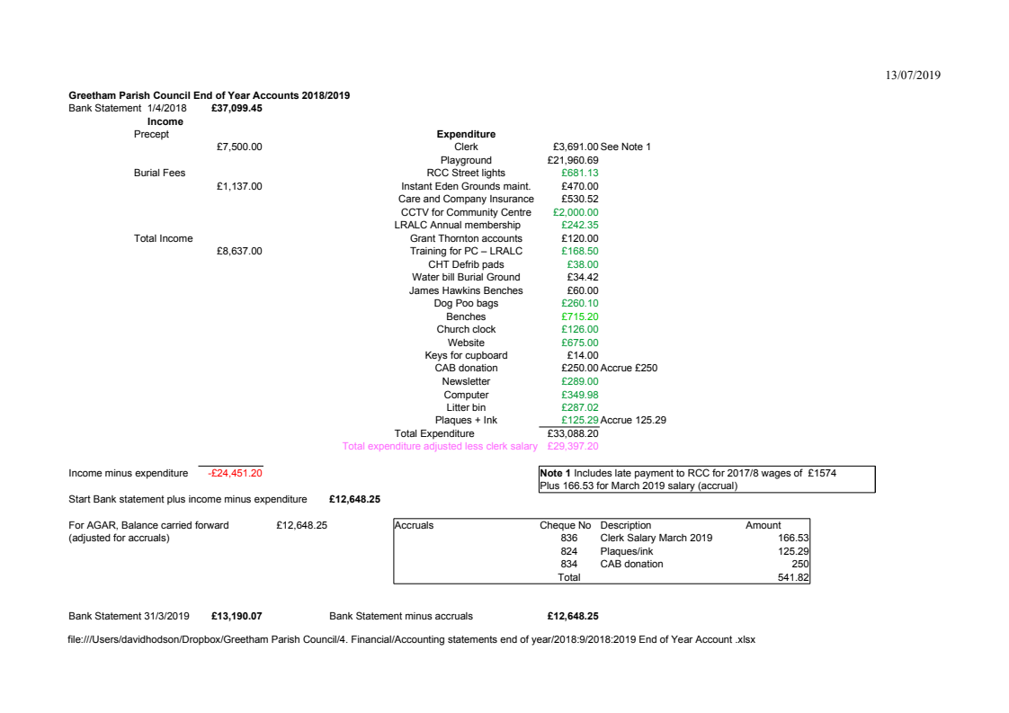
- An End of Year Account will be produced as per the following format.

- Internal Audit/ AGAR
  - The RFO will arrange for an Internal Audit during April and present all resulting reports to the Parish Council.
  - Internal or external auditors may not under any circumstances:
    - perform any operational duties for the Council.
    - initiate or approve accounting transactions; or
    - direct the activities of any Council employee, except to the extent that such employees have appropriately assigned to assist the internal auditor
  - The RFO will then draft the Annual Governance & Accountability Report for approval by the Parish Council.
- Asset Register
The RFO will maintain and keep up to date an asset register.
This will include (where appropriate) a photograph of the asset, its purchase price, date of acquisition and current replacement value and location.
- Insurance
  - The Parish Council will review its insurance policy at the Annual meeting each year and verify that a policy is in place.
  - The Parish Council will hold insurance against Employer’s liability, Public Liability, Property loss / damage and Fidelity Guarantee
- Transparency
The Transparency Regulation require that all items of expenditure greater than £100 will be published on the Parish Council website. As all expenditure is published on the website, no further publishing is required.
- Disposal of assets.
The disposal of any disposal asset must be approved at a Parish Council meeting.
- The Clerk shall make appropriate arrangements for the custody of all title deeds and Land Registry Certificates of properties held by the Council
- Risk Management
  - The Council is responsible for putting in place arrangements for the management of risk. The Clerk with the RFO shall prepare, for approval by the Council, risk management policy statements in respect of all activities of the Council. Risk policy statements and consequential management arrangements shall be reviewed annually.
  - When considering any new activity, the Clerk with the RFO shall prepare a draft risk assessment including risk management proposals for consideration and adoption by the Council.
- Suspension and revision of Financial Regulations
The Council may, by resolution of the Council duly notified prior to the relevant meeting of the Council, suspend any part of these Financial Regulations provided that reasons for the suspension are recorded and the assessment of the risks arising has been drawn up and presented in advance to all members of the Council.

Appendix 6 Advisory Teams
An Advisory Team is defined as a ‘non-committee’ structured informal assemblage.
The Council may appoint an Advisory Team as follows:
Purpose:
- To gather information, explore options and propose potential strategies for predefined subject areas
- Prohibition
- Advisory Teams must not make any decision which obligates Greetham Parish Council to any policy, expenditure or action, without a proposal to full committee.
- Making purpose clear in dealings with third parties
- In all their dealings with other persons the Team must make it clear what their role is and its limitations.
- Membership
(Note: All Parish Councillors are expected to join Teams to spread the work load.)
- A Team will require a Leader and all Team Members must commit time and effort.
- Team Leaders can re-organise teams and re-allocate parish councillors as members.
- Membership of the group is restricted to 3 Parish Councillors or less. (This is to prevent any group having a majority voting position on the full council).
- Additionally, members of public may be co-opted onto the Team
- Reporting
- Individual group members are accountable for reporting back their activities to other group member. The group should regularly report to the Parish Council.
- At whatever time the Chairman of the Parish Council may call upon a Team to account for its actions.
- Teams will provide a monthly update via a pro-forma Group Report
- Meetings
- The Team will meet as and when required to review the relevance and value of its work
- Advisory Teams should keep notes of the key points of their meetings. Day to day secretariat duties will be carried out by group members and not by the Parish Council clerk.
- Sharing of information
- All communication with the public is to be agreed at a Parish Council meeting and conveyed through the minutes as a decision of that meeting.
- Any form of report, presentation or recommendation made by any Advisory Teams will be made on the understanding that the Parish Council (and only the Parish Council) will ratify and take forward any action agreed as by them.

- Confidentiality
Team Members shall not disclose information given in confidence or which they believe or ought to be aware is of a confidential nature, or divulge the workings of the group to the public without the approval of the Parish Council.

Significant Planning Applications Street and Services Environment Planning
Team Team Team

Quarries Traffic Biodiversity Plans 10years
Large developments Roads & Pavements Covering
Planning breaches Fix My Street Hedgerows & Woodlands
Quarry liaison and RQF Grass cutting contract Trees
Benches & Street Furniture Watercourses & Ponds
Lighting Wildflower Meadows
Village tidy X 2 per annum Drainage & Sewage
Utilities

Leader Leader Leader
+ 2 Councillors + 2 Councillors + Any Councillors
+ Any Members of Public
+ Leader RQF +public if appropriate

Tree Warden to advise on tree planning Issues Decision by full PC

Burial Ground handled by Clerk & Chair Community Centre liaison 3 X Councillors as Trustees on CC Committe
Appendix 7 Co-option process

In the event that there is a vacancy for a parish councillor to be filled by co-option, the following process will be used:
- The clerk will request existing Parish Councillors to put forward suitable nominations that are willing to serve.
- The nominated persons will be asked to confirm their suitability and asked to attend the parish council meeting at which the co-option will be considered.
- The nominated person will be invited to speak for no more than three minutes on their reasons for wanting to be on the parish council, should they wish to do so.
- A vote will then be by a show of hands. (Only persons at the meeting may vote).
- In the case of equality of votes, the Chairman will have a casting vote. The Chairman will then declare who is the preferred candidate, who will immediate become a parish council or with the same rights as all other councillors.

Appendix 8 Transparency Regulations
The Department for Communities and Local Government issued a Transparency code in December 2014 – Transparency code for smaller authorities, which specifies information which Parish Councils should publish.

Greetham Parish Council publishes this information on the village website – www.greethamrutland.com .

Appendix 9 Safeguarding Policy

Policy Statement
- In the interests of child protection and the welfare and protection of vulnerable adults, the Parish Council is committed to ensuring that children and vulnerable adults are protected and kept safe from harm whilst they are engaged in any activity associated with the Parish Council.
Policy Objective:
- To ensure that where possible all facilities and activities offered by the Parish Council are designed and maintained to limit risk to children and vulnerable adults.
- To promote the general welfare, health and development of children by being aware of child protection issues and to be able to respond where appropriate as a local government organisation.
- To develop procedures in recording and responding to accidents and complaints and to alleged or suspected incidents of abuse and neglect.
- As the Parish Council does not directly provide care of supervision services to children and vulnerable adults, it expects all children and vulnerable adults using its facilities to do so with the consent and the necessary supervision of a parent, carer or other responsible adult.
Aims
- The aim of this policy document is to guide members of the Parish Council and any co- opted members of Committees should any child protection issue or any issues with vulnerable adults arise during their work.
Responsibilities & Procedures
- The Clerk has been designated as Safeguarding Officer and the responsibilities will include:
- Ensuring that participants are appropriately briefed before any Parish Council organised event with children or vulnerable people;
- Ensuring that members are aware of the risk they may face in certain circumstances whilst carrying out their duties;
- Ensuring, that whilst Council members are unlikely to be involved with children during the performance of their duties they are mindful of the risk they face;
- Ensuring that before any volunteers or paid members of staff are recruited to work with children and vulnerable persons they are interviewed and two references taken up;
- Decisions on whether any person should be DBS checked will be made by the Council, or the Clerk after consultation with the Chairman, following a risk assessment.
- All new Councillors are to be provided with a copy of the Safeguarding Policy and are required to acknowledge they will abide by it.
- Councillors will adhere to the ‘List of Recommended Behaviour’ namely:
- A minimum of two adults present when supervising children.
- Not to play physical contact games.
- Adults to wear appropriate clothing at all times.
- Ensure that accidents are recorded in an accident book.
- Never do anything of a personal nature for a young person.
- Keep records in an incident book of any allegations a young person may make to any committee member or volunteer.
- If there is a child abuse incident it should be reported to the Safeguarding Officer who will be responsible for ensuring the matter is handled in accordance with the Local Safeguarding Children Board procedures and also referred to the Council for further action as appropriate and future risk assessment.
- Facilities offered by the Parish Council have been inspected on a regular basis and at least annually by a representative of RoSPA or a similar organisation.
- Sharing information about child protection and good practice with partner organisations, councillors, employees, volunteers, parents and carers.
- In the event of a contractor, working directly for the Parish Council, being deemed to be working in any area where children or vulnerable adults may be at risk, then that contractor will be asked to provide their Safeguarding Policy.
- Any organisation which may make contact with children or vulnerable adults shall be required to show proof of its own appropriate Safeguarding Policy before being allowed to participate in the use of any council-owned facilities.
Declaration
Greetham Parish Council is fully committed to safeguading the well-being of children and vulnerable adults by protecting them from physical, sexual, emotional harm and neglect.

Appendix 10 Equality Policy
1. POLICY STATEMENT

The Parish Council is committed to pursuing an equal opportunities approach in the employment of its staff and in every aspect of Council activity and recognises its statutory duties under legislation in terms of service provision and employment and is committed to meet them by complying with this policy.

2. LEGAL POSITION

It is unlawful to discriminate against an individual on the following grounds:
• age • disability • gender reassignment • marriage and civil partnership • pregnancy and maternity • race • religion or belief • sex • sexual orientation
Under the Equality Act 2010 these are known as “protected characteristics”.
It is unfair to discriminate against an individual on the following grounds:- • political views • Family or caring responsibilities • Chronic illness or HIV/ Aids status • Socio Economic Status.

3. PURPOSE

The purpose of this policy is to provide equal opportunities to all employees, irrespective of their characteristics (unless there are genuine occupational qualifications or objectively justified reasons for a different approach to be taken) and an equality of opportunity in the provision of services and access to Parish Council facilities. The Council opposes all forms of unlawful and unfair discrimination whether it be direct or indirect discrimination, victimization or harassment on the grounds of any of the protected characteristics defined in the Equality Act 2010 or the identified additional unfair grounds. The Equality Policy underpins all policies, procedures and strategies, therefore providing a strong foundation for equality in the Council and the services it provides.

4. EQUALITY OF OPPORTUNITY IN EMPLOYMENT, TRAINING AND ORGANISATIONAL DEVELOPMENT

All employees whether full-time, part-time, fixed term contract, agency workers or temporary staff, will be treated fairly and equally. Selection for employment, promotion, training, remuneration or any other benefit will be on the basis of aptitude and ability. All employees will be helped and encouraged to develop their full potential and the talents and resources of the workforce will be fully utilised to maximise the efficiency of the council.
Every employee is entitled to a working environment that promotes dignity and respect to all. No form of intimidation, bullying or harassment will be tolerated. This is further defined in the Dignity at Work policy adopted by the council.
The commitment to equal opportunities in the workplace is good management practice and makes sound business sense as it seeks to utilise the talents available from the local community, representing Society as a whole.
Breaches of the Parish Council’s equal opportunities policy will be regarded as serious misconduct and could lead to disciplinary proceedings. Employees are entitled to complain about discrimination or harassment or victimization through the council’s Grievance procedure.
Prospective candidates wishing to raise a complaint should do so, in writing, to the Clerk within 15 working days, at the latest, of the alleged incident. An investigation will then be conducted by the Clerk, or an independent person appointed for the purpose, who will report to the Council.

5. EQUALITY OF OPPORTUNITY IN SERVICE DELIVERY.

The Parish Council is committed to equality of opportunity in the provision of services and access to its facilities. The Council will deliver services that are relevant, of the highest quality possible and accessible. Training in relation to the roles and responsibilities of employees and the Council in delivering services will be sought and undertaken.

6. COMMITMENT

The Parish Council will comply with all current and future legislation referring to equality and diversity and will aim to promote good practice in all aspects of the organisation. The Council will publicise this policy on its website and will highlight it in recruitment and relevant official documentation.

Advice from LRALC is that this only applies to byelaws made by Rutland County Council and applicable to Greetham.
Currently it has been found impractical to obtain three quotes for horticultural work of value less than £100.
See JPAG Governance and Accountability for Smaller Authorities in England for guidance.
i.e eligible persons as per election regulations.
They will be sent a copy of eligibility requirements

